CN LAB 3 TASKS
Hamza Farhan
24K-0576
TASK 1
Server:
import socket

s=socket.socket()
s.bind(('localhost', 9999))
s.listen(5)
print('Server is listening...')

while True:
c, addr= s.accept()
print('Got connection from', addr)
data=c.recv(1024).decode()
print('Received data:', data)
if not data:
c.close()
break
num1,num2,op=data.split(",")
num1=int(num1)
num2=int(num2)
if op == '+':
res = num1 + num2
elif op == '-':
res = num1 - num2
elif op == '*':
res = num1 * num2
elif op == '/':
res = num1 / num2 if num2 != 0 else "Error: Division by zero"
else:
res = "Error: Invalid operator"
f=open("history.txt","a")
f.write(f"client {num1} {op} {num2} = {res}\n")
f.close()

c.send(bytes(f"result: {res}",'utf-8'))

Client:
import socket

num1 = input("Enter first number: ")
num2 = input("Enter second number: ")
op = input("Enter operation (+, -, *, /): ")

data=f"{num1},{num2},{op}"

s=socket.socket()
s.connect(('localhost', 9999))

s.send(bytes(data,'utf-8'))
result=s.recv(1024).decode()
print(result)
s.close()
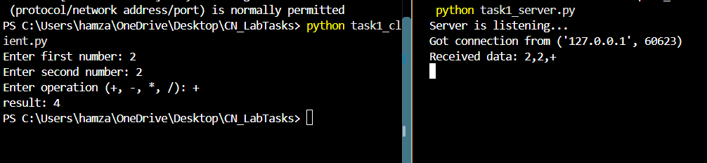
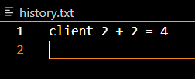

TASK 2
Server:
import socket
s=socket.socket()
s.bind(('localhost', 9999))
s.listen(5)
print("Server is listening on port 9999...")

while True:
c, addre=s.accept()
print("got connection from", addre)
data = c.recv(1024).decode()
print("Received data:", data)
if not data:
c.close()
continue

gp=float(data)
if gp >= 4.33:
result = "Letter Grade: A+ | Qualification: Excellent"
elif gp >= 4.00:
result = "Letter Grade: A | Qualification: Excellent"
elif gp >= 3.66:
result = "Letter Grade: A- | Qualification: Very good"
elif gp >= 3.33:
result = "Letter Grade: B+ | Qualification: Very good"
elif gp >= 3.00:
result = "Letter Grade: B | Qualification: Very good"
elif gp >= 2.66:
result = "Letter Grade: B- | Qualification: Good"
elif gp >= 2.33:
result = "Letter Grade: C+ | Qualification: Good"
elif gp >= 2.00:
result = "Letter Grade: C | Qualification: Good"
elif gp >= 1.66:
result = "Letter Grade: C- | Qualification: Passable"
elif gp >= 1.33:
result = "Letter Grade: D+ | Qualification: Passable"
elif gp >= 1.00:
result = "Letter Grade: D | Qualification: Passable"
else:
result = "Letter Grade: E | Qualification: Failure"
c.send(bytes(result, "utf-8"))
c.close()

Client:
import socket

num=input("Enter your GPA: ")
num=float(num)

s=socket.socket()
s.connect(('localhost', 9999))
s.send(bytes(str(num),"utf-8"))

resp=s.recv(1024).decode()
print("Server response:", resp)
s.close()

